EC-467 Mobile Application Development
ALL LAB REPORTS
BY
Huzaifa Shahbaz
LAB REPORT#1
Development Environment and Gradle
Introduction: The goal of this course is to teach the skills necessary to develop Android based applications using the Android Studio Integrated Development Environment (IDE) and the Android Software Development Kit (SDK).Beginning with the basics, this course provides an outline of the steps necessary to set up an Android development and testing environment. An overview of Android Studio is included covering are as such as tool windows, the code editor and the Designer tool. An introduction to the architecture of Android is followed by an in-depth look at the design of Android applications and user interfaces using the Android Studio environment. More advanced topics such as database management, content providers and intents are also covered, as are touch screen handling, camera access. Lab manuals of this course also cover advanced features of Android Studio such as Gradle build configuration and the implementation of build variants to target multiple. Android device types from a single project code base. Assuming you already have some Java programming experience, are ready to download Android Studio and the Android SDK, have access to a Windows, Mac or Linux system and ideas for some apps to develop, you are ready to get started.
Gradle: Gradle is an open-source build automation system that builds upon the concepts of Apache Ant and Apache Maven and introduces a Groovy-based domain-specific language (DSL) instead of the XML form used by Apache Maven for declaring the project configuration. Maven is a build automation tool used primarily for Java projects. Maven addresses two aspects of building software: first, it describes how software is built and second, it describes its dependencies.
Tools:
Android Studio 1.1
Practice Task:
This section will provide information about the practice tasks, which are required to be performed in lab session. Design solutions of problems discussed in each task and place the solution code in a folder specified.
Solution:
In this lab we just introduced the android studio programming web application.
Steps: 1. Go the web, first and foremost, application (Download android studio in your google search bar). 2.Besides click the download android studio iguana. 3.Presently trust that the application will get downloaded. 4.After this you can fire set up your android studio by following given advances. 5.In the wake of setting up your android studio you can begin your essential assignments.
Shortcomings: The main came from the rendition that Gradle was not coordinating with the few recent variants of the android studio. The subsequent inadequacy came from the working of the emulator. The emulator was not working accurately because of the SDK manager and the API device was also not working properly in the android studio.
Troubleshooting: For the main weakness I choose the SDK manager and I choose the redesign and install the latest version of API level which made it work accurately. Now the second weakness of the I choose the layout because I need to make layout of the phone which I went to the emulator setting to the emulator and choose the latest version of the emulator in the android studio.After,all these investigation, my android studio work very smooth and efficient and got set up and I could at long last make my venture and get everything to work.
Conclusion: In this lab, we learned how to install and set up the android studio application.
LAB REPORT#2
Activity with GUI and Click Listener
Introduction: The goal of this lab is to teach the skills necessary to create Activities in Android applications using the Android Studio Integrated Development Environment (IDE) and the Android Software Development Kit (SDK). This lab will provide an outline of Android Activity with GUI. Activity is one of the building blocks of Android OS. In simple words Activity is a screen that user interact with. Every Activity in android has lifecycle like created, started, resumed, paused, stopped or destroyed. Basic GUI components are Text Views, Buttons, Image Views and Fragments.
Objectives of the experiment: 1.To get basic understanding regarding Android App Development. 2. To build a mobile app in android studio 3.To understand the GUI components of Android
Tools: Android Studio Iguana
Class Task: JAVA CODE OF MAIN ACTIVITY:
package com.huzaifashahbaz.nameapp;
import android.os.Bundle;
import android.view.View;
import android.widget.Button;
import android.widget.EditText;
import android.widget.TextView;
import android.widget.Toast;
import androidx.activity.EdgeToEdge;
import androidx.appcompat.app.AppCompatActivity;
import androidx.core.graphics.Insets;
import androidx.core.view.ViewCompat;
import androidx.core.view.WindowInsetsCompat;
public class MainActivity extends AppCompatActivity {
private Button showDialogButton;
private EditText userEditText;
private TextView userTextView;
private String toastMessage;
@Override
protected void onCreate(Bundle savedInstanceState) {
super.onCreate(savedInstanceState);
setContentView(R.layout.activity_main);
toastMessage=getString(R.string.string_toast_hello);
showDialogButton=findViewById(R.id.show_dialog_button);
userEditText=findViewById(R.id.user_edit_text);
userTextView=findViewById(R.id.userTextView);
showDialogButton.setOnClickListener(new View.OnClickListener() {
@Override
public void onClick(View view) {
Toast.makeText(MainActivity.this, toastMessage + userEditText.getText(), Toast.LENGTH_SHORT).show();
userTextView.setText(toastMessage + userEditText.getText());
}
});
}
}
XML CODE OF MAIN ACTIVITY:
<?xml version="1.0" encoding="utf-8"?>
<LinearLayout xmlns:android="http://schemas.android.com/apk/res/android"
xmlns:tools="http://schemas.android.com/tools"
android:layout_width="match_parent"
android:layout_height="match_parent"
android:orientation="vertical"
tools:context=".MainActivity">
<EditText
android:id="@+id/user_edit_text"
android:layout_width="match_parent"
android:layout_height="wrap_content"
android:hint="Enter your name"
android:inputType="text" />
<Button
android:id="@+id/show_dialog_button"
android:layout_width="match_parent"
android:layout_height="wrap_content"
android:layout_marginTop="16dp"
android:text="Update" />
<TextView
android:id="@+id/userTextView"
android:layout_width="wrap_content"
android:layout_height="wrap_content"
android:text="Hello,you have entered Huzaifa"
android:layout_marginTop="16dp" />
</LinearLayout>
Results:
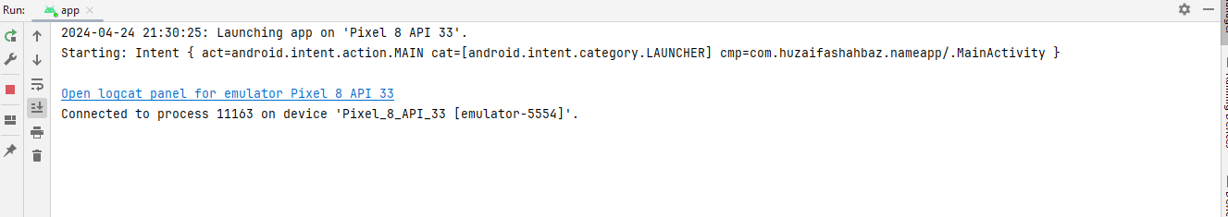
Output:
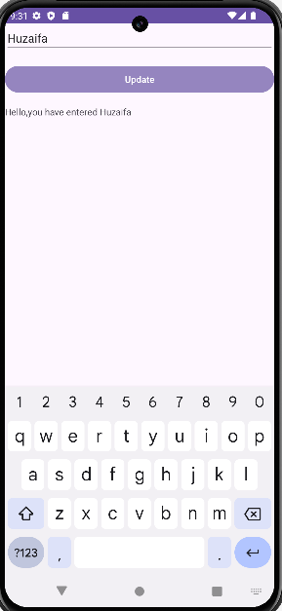
Home Task: Create an simple “tasbeeh” app what update “tasbeeh” counter on press of each button press.
JAVA CODE OF MAIN ACTIVITY:
package com.huzaifashahbaz.tasbeehapp;
import android.os.Bundle;
import android.view.View;
import android.widget.Button;
import android.widget.TextView;
import android.widget.Toast;
import androidx.activity.EdgeToEdge;
import androidx.appcompat.app.AppCompatActivity;
import androidx.core.graphics.Insets;
import androidx.core.view.ViewCompat;
import androidx.core.view.WindowInsetsCompat;
public class MainActivity extends AppCompatActivity {
private int Counter=0;
@Override
protected void onCreate(Bundle savedInstanceState) {
super.onCreate(savedInstanceState);
setContentView(R.layout.activity_main);
Button buttons=findViewById(R.id.button);
TextView txtview=findViewById(R.id.textview);
buttons.setOnClickListener(new View.OnClickListener() {
@Override
public void onClick(View view) {
Counter++;
txtview.setText(Integer.toString(Counter));
Toast.makeText(MainActivity.this, "JAZAKALLAH", Toast.LENGTH_SHORT).show();
}
});
}
}
XML CODE OF MAIN ACTIVITY:
<?xml version="1.0" encoding="utf-8"?>
<LinearLayout xmlns:android="http://schemas.android.com/apk/res/android"
xmlns:app="http://schemas.android.com/apk/res-auto"
xmlns:tools="http://schemas.android.com/tools"
android:layout_height="match_parent"
android:layout_width="match_parent"
android:orientation="vertical"
tools:context=".MainActivity">
<Button
android:id="@+id/button"
android:layout_width="match_parent"
android:layout_height="91dp"
android:text="Count"
android:textSize="30sp"/>
<TextView
android:id="@+id/textView"
android:layout_width="399dp"
android:layout_height="71dp"
android:text="0"
android:textColor="blue"
android:textSize="30sp"/>
</LinearLayout>
Results:
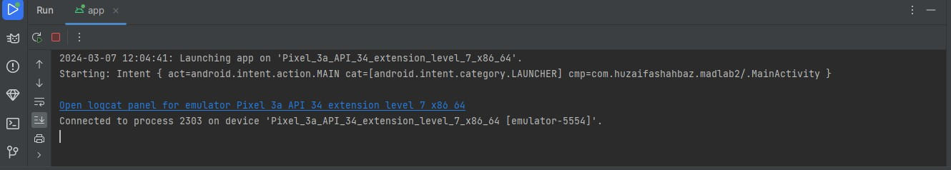
Output:
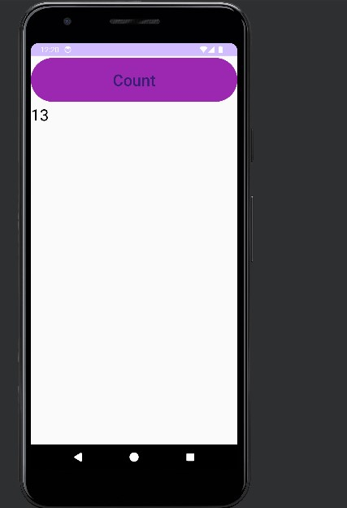
Conclusion: In conclusion, we learn how to make the tasbeeh counter and its working application and also we implement in java code and design in XML.

LAB REPORT#3
Activity with GUI and Layout
Introduction: Creating a good GUI is a very tough task as different users prefer different things in GUI and developer has to come up with something that is both easy to use and good looking. Some parts of GUI were discussed in the previous lab, other parts of GUI consists of Views like grid views and scroll views, Layouts like Linear Layout and Relative Layout and some graphical components like Spinners, Edit-Texts, Radio buttons and toggle button etc. Android Layout types are Linear Layout, Relative Layout Coordinate Layout, Table Layout and Fragment Layout. Linear layout is a simple layout used in android for layout designing. In the Linear layout all the elements are displayed in linear fashion means all the child’s/elements of a linear layout are displayed according to its orientation. The value for orientation property can be either horizontal or vertical.
Objectives of the experiment: 1. To get basic understanding of Layouts. 2.Implement layout using Linear & relative layout. 3. Perform the task in the lab.
Tools: Android Studio Iguana
JAVA CODE OF MAIN ACTIVITY:
package com.huzaifashahbaz.tasbeehcounterapp;
import android.os.Bundle;
import android.view.View;
import android.widget.Button;
import android.widget.TextView;
import android.widget.Toast;
import androidx.activity.EdgeToEdge;
import androidx.appcompat.app.AppCompatActivity;
import androidx.core.graphics.Insets;
import androidx.core.view.ViewCompat;
import androidx.core.view.WindowInsetsCompat;
public class MainActivity extends AppCompatActivity {
TextView tvCount;
Button btnCount,btnReset,btnViewHistory;
int Count=0;
@Override
protected void onCreate(Bundle savedInstanceState) {
super.onCreate(savedInstanceState);
setContentView(R.layout.activity_main);
tvCount=findViewById(R.id.text_view_count);
}
public void onPressResetbtn(View view)
{
Count=0;
tvCount.setText("Count:" + Count);
}
public void onPressHistorybtn(View view)
{
Toast.makeText(this, "JAZAKALLAJKHAIR", Toast.LENGTH_SHORT).show();
}
public void onPressCountbtn(View view)
{
Count++;
tvCount.setText("Count:"+Count);
}
}
XML CODE OF MAIN ACTIVITY:
<?xml version="1.0" encoding="utf-8"?>
<LinearLayout xmlns:android="http://schemas.android.com/apk/res/android"
xmlns:app="http://schemas.android.com/apk/res-auto"
xmlns:tools="http://schemas.android.com/tools"
android:layout_width="match_parent"
android:layout_height="match_parent"
android:gravity="center"
android:orientation="vertical"
tools:context=".MainActivity">
<TextView
android:id="@+id/textView"
android:layout_width="131dp"
android:layout_height="wrap_content"
android:text="TextView"
tools:layout_editior_absoluteX="267dp"
tools:layout_editior_absoluteY="142dp"/>
<LinearLayout
android:layout_width="match_parent"
android:layout_height="wrap_content"
android:orientation="horizontal">
<Button
android:id="@+id/btn_count_1"
android:layout_width="142dp"
android:layout_height="wrap_content"
android:onClick="onPressCountbtn"
android:text="Count"
tools:layout_editior_absoluteX="198dp"
tools:layout_editior_absoluteY="156dp"/>
<Button
android:id="@+id/btn_Rest_1"
android:layout_width="246dp"
android:layout_height="wrap_content"
android:onClick="onPressResetbtn"
android:text="Reset"
tools:layout_editior_absoluteX="247dp"
tools:layout_editior_absoluteY="224dp" />
</LinearLayout>
<Button
android:id="@+id/ViewHistory"
android:layout_width="match_parent"
android:layout_height="wrap_content"
android:onClick="onPressHistorybtn"
android:text="ViewHistory"
tools:layout_editior_absoluteX="296dp"
tools:layout_editior_absoluteY="153dp" />
</LinearLayout>

Results:
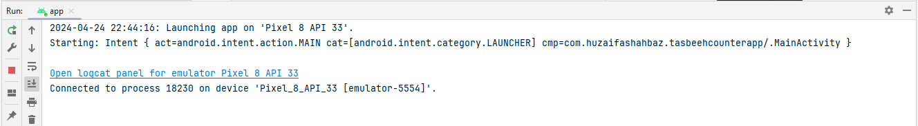
Output:
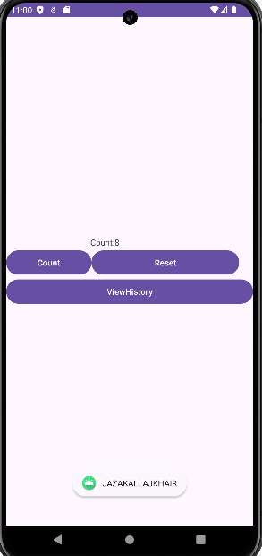
Home Task:
JAVA CODE OF MAIN ACTIVITY:
package com.huzaifashahbaz.loginapp;
import android.os.Bundle;
import android.view.View;
import android.widget.Button;
import android.widget.EditText;
import android.widget.RadioButton;
import android.widget.RadioGroup;
import android.widget.TextView;
import android.widget.Toast;
import androidx.activity.EdgeToEdge;
import androidx.appcompat.app.AppCompatActivity;
import androidx.core.graphics.Insets;
import androidx.core.view.ViewCompat;
import androidx.core.view.WindowInsetsCompat;
private EditText mUsernameEditText;
private EditText mEmailEditText;
private EditText mPasswordEditText;
private RadioGroup mGenderRadioGroup;
private Button mRegisterButton;
private TextView mAlreadyRegisteredTextView;
@Override
protected void onCreate(Bundle savedInstanceState) {
super.onCreate(savedInstanceState);
setContentView(R.layout.activity_main);
mUsernameEditText = findViewById(R.id.usernameEditText);
mEmailEditText = findViewById(R.id.emailEditText);
mPasswordEditText = findViewById(R.id.passwordEditText);
mGenderRadioGroup = findViewById(R.id.genderRadioGroup);
mRegisterButton = findViewById(R.id.registerButton);
mAlreadyRegisteredTextView = findViewById(R.id.alreadyRegisteredTextView);
mRegisterButton.setOnClickListener(new View.OnClickListener() {
@Override
public void onClick(View view) {
String username = mUsernameEditText.getText().toString();
String email = mEmailEditText.getText().toString();
String password = mPasswordEditText.getText().toString();
int genderId = mGenderRadioGroup.getCheckedRadioButtonId();
RadioButton genderRadioButton = findViewById(genderId);
String gender = genderRadioButton.getText().toString();
// Validate form input
if (username.isEmpty() || email.isEmpty() || password.isEmpty() || gender.isEmpty()) {
Toast.makeText(RegistrationActivity.this, "Please fill out all fields", Toast.LENGTH_SHORT).show();
return;
}
// TODO: Send registration data to server or database
// Clear form input
mUsernameEditText.setText("");
mEmailEditText.setText("");
mPasswordEditText.setText("");
mGenderRadioGroup.clearCheck();
Toast.makeText(RegistrationActivity.this, "Registration successful!", Toast.LENGTH_SHORT).show();
}
});
mAlreadyRegisteredTextView.setOnClickListener(new View.OnClickListener() {
@Override
public void onClick(View view) {
// TODO: Navigate to login screen
}
});
}
}
XML CODE: <LinearLayout
xmlns:android="http://schemas.android.com/apk/res/android"
android:layout_width="match_parent"
android:layout_height="match_parent"
android:orientation="vertical"
android:padding="16dp">
<EditText
android:id="@+id/usernameEditText"
android:layout_width="match_parent"
android:layout_height="wrap_content"
android:hint="Username"
android:minHeight="48dp" />
<EditText
android:id="@+id/emailEditText"
android:layout_width="match_parent"
android:layout_height="wrap_content"
android:hint="Email"
android:inputType="textEmailAddress"
android:minHeight="48dp" />
<EditText
android:id="@+id/passwordEditText"
android:layout_width="match_parent"
android:layout_height="wrap_content"
android:hint="Password"
android:inputType="textPassword"
android:minHeight="48dp" />
<RadioGroup
android:id="@+id/genderRadioGroup"
android:layout_width="wrap_content"
android:layout_height="wrap_content"
android:orientation="horizontal"
android:onClick="onPressRadioGroupbtn">
<RadioButton
android:id="@+id/maleRadioButton"
android:layout_width="wrap_content"
android:layout_height="wrap_content"
android:onClick="onPressMalebtn"
android:text="Male" />
<RadioButton
android:id="@+id/femaleRadioButton"
android:layout_width="wrap_content"
android:layout_height="wrap_content"
android:onClick="onPressFemalebtn"
android:text="Female" />
</RadioGroup>
<Button
android:id="@+id/registerButton"
android:layout_width="wrap_content"
android:layout_height="wrap_content"
android:layout_gravity="center_horizontal"
android:onClick="onPressRegisterbtn"
android:text="Register" />
<TextView
android:id="@+id/alreadyRegisteredTextView"
android:layout_width="wrap_content"
android:layout_height="wrap_content"
android:layout_gravity="center_horizontal"
android:text="Already Registered?" />
<Button
android:id="@+id/loginButton"
android:layout_width="wrap_content"
android:layout_height="wrap_content"
android:layout_gravity="center_horizontal"
android:onClick="onPressLoginHerebtn"
android:text="Login Here" />
</LinearLayout>
Results:
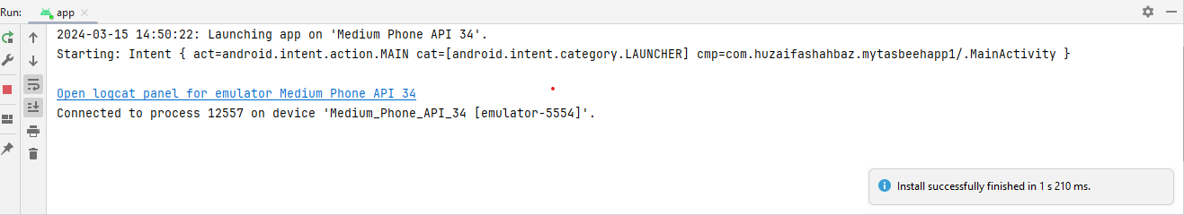
OUTPUT:
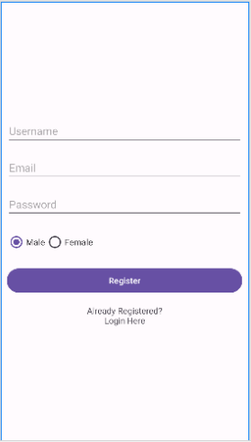
Conclusion: In conclusion, we had know how to make the tasbeeh counter app and registration form by performing java code and xml code(Linear Layout).Also we saw their working ,construction and functions in frontend and backend of the mobile app.

LAB REPORT#4
Multiple Activity and Intents
Introduction: An Intent is a simple message object that is used to communicate between android components such as activities, content providers, broadcast receivers and services. Intents are also used to transfer data between activities. Android application components can connect to other Android applications. This connection is based on a task description represented by an Intent object. Intents are asynchronous messages which allow application components to request functionality from other Android components. Intents allow you to interact with components from the same applications as well as with components contributed by other applications. For example, an activity can start an external activity for taking a picture.
Objectives of the experiment: 1. To get basic understanding regarding Intents 2. To know about the intent 3. To be able to use Intents in your app 4.To get to know about the benefits related to intents
Tools: Android Studio Iguana
Class Task:
JAVA CODE OF MAIN ACTIVITY;
package com.huzaifashahbaz.studentforamapp;
import android.os.Bundle;
import android.view.View;
import android.widget.Button;
import android.widget.EditText;
import android.content.Intent;
import androidx.activity.EdgeToEdge;
import androidx.appcompat.app.AppCompatActivity;
import androidx.core.graphics.Insets;
import androidx.core.view.ViewCompat;
import androidx.core.view.WindowInsetsCompat;
public class MainActivity extends AppCompatActivity {
@Override
protected void onCreate(Bundle savedInstanceState) {
super.onCreate(savedInstanceState);
setContentView(R.layout.activity_main);
EditText editTextName,editTextFatherName,editTextReg,editTextCGPA,editTextSemester;
Button btnSave;
editTextName=(EditText) findViewById(R.id.et_Name);
editTextFatherName=(EditText) findViewById(R.id.et_FatherName);
editTextReg=(EditText) findViewById(R.id.et_Reg);
editTextCGPA=(EditText) findViewById(R.id.et_CGPA);
editTextSemester=(EditText) findViewById(R.id.et_Semester);
btnSave=(EditText) findViewById(R.id_btn_Save);
btnSave.setOnClickListener(new View.OnClickListener() {
public void onClick(View view) {
String name,fname,reg,cgpa,semester;
name = editTextName.getText().toString();
fname = editTextFatherName.getText().toString();
reg = editTextReg.getText().toString();
cgpa = editTextCGPA.getText().toString();
semester = editTextSemester.getText().toString();
Intent intObj = new Intent( MainActivity.this, NextActivity.class );
intObj.putExtra( "USERNAME", name );
intObj.putExtra( "FATHERNAME", fname );
intObj.putExtra( "REG", reg );
intObj.putExtra( "CGPA", cgpa );
intObj.putExtra( "SEMESTER", semester );
startActivity( intObj );
}
});
}
}
XML CODE OF MAIN ACTIVITY:
<?xml version="1.0" encoding="utf-8"?>
<LinearLayout xmlns:android="http://schemas.android.com/apk/res/android"
xmlns:app="http://schemas.android.com/apk/res-auto"
xmlns:tools="http://schemas.android.com/tools"
android:layout_width="match_parent"
android:layout_height="match_parent"
android:orientation="vertical"
android:padding="10dp">
<TextView
android:id="@+id/tv_Home"
android:layout_width="wrap_content"
android:layout_height="wrap_content"
android:text="Enter Data"
android:textSize="30sp"
android:layout_marginTop="100dp"
android:layout_marginBottom="20dp"/>
<EditText
android:id="@+id/et_Name"
android:layout_width="match_parent"
android:layout_height="40dp"
android:hint=" Name"
android:background="#fff"
android:lines="1" />
<EditText
android:id="@+id/et_FatherName"
android:layout_width="match_parent"
android:layout_height="40dp"
android:background="#fff"
android:layout_marginTop="10dp"
android:hint=" Father's Name"
android:lines="1"/>
<EditText
android:id="@+id/et_Reg"
android:layout_width="match_parent"
android:layout_height="40dp"
android:background="#fff"
android:layout_marginTop="10dp"
android:hint=" Reg #"
android:lines="1"/>
<EditText
android:id="@+id/et_CGPA"
android:layout_width="match_parent"
android:layout_height="40dp"
android:background="#fff"
android:layout_marginTop="10dp"
android:hint=" CGPA"
android:lines="1"/>
<EditText
android:id="@+id/et_Semester"
android:layout_width="match_parent"
android:layout_height="40dp"
android:background="#fff"
android:layout_marginTop="10dp"
android:hint=" Semester"
android:lines="1"/>
<Button
android:id="@+id/btn_Save"
android:layout_width="wrap_content"
android:layout_height="wrap_content"
android:layout_marginTop="25dp"
android:background="#fff"
android:text="Save"
android:textSize="20sp"/>
</LinearLayout>
JAVA CODE OF MAIN ACTIVITY:
package com.huzaifashahbaz.studentforamapp;
import android.content.Intent;
import android.os.Bundle;
import android.widget.TextView;
import androidx.activity.EdgeToEdge;
import androidx.appcompat.app.AppCompatActivity;
import androidx.core.graphics.Insets;
import androidx.core.view.ViewCompat;
import androidx.core.view.WindowInsetsCompat;
public class NextActivity extends AppCompatActivity {
TextView txtName,txtFatherName,txtReg,txtCGPA,txtSemester;
@Override
protected void onCreate(Bundle savedInstanceState) {
super.onCreate(savedInstanceState);
setContentView(R.layout.activity_next);
txtName=(TextView) findViewById(R.id.textviewName);
txtFatherName=(TextView) findViewById((R.id.textviewFatherName));
txtReg=(TextView) findViewById(R.id.textviewReg);
txtCGPA=(TextView) findViewById(R.id.textviewCGPA);
txtSemester=(TextView) findViewById(R.id.textviewSemester);
Intent getintObj=getIntent();
String uname=(String) getintObj.getStringExtra("USERNAME");
String fname=(String) getintObj.getStringExtra("FATHERNAME");
String reg=(String) getintObj.getStringExtra("REG");
String CGPA=(String) getintObj.getStringExtra("CGPA");
String Semester=(String) getintObj.getStringExtra("Semester");
txtName.setText(uname);
txtFatherName.setText(fname);
txtReg.setText(reg);
txtCGPA.setText(CGPA);
txtSemester.setText(Semester);
}
}
XML CODE OF NEXT ACTIVITY:
<?xml version="1.0" encoding="utf-8"?>
<LinearLayout xmlns:android="http://schemas.android.com/apk/res/android"
xmlns:app="http://schemas.android.com/apk/res-auto"
xmlns:tools="http://schemas.android.com/tools"
android:layout_width="match_parent"
android:layout_height="match_parent"
android:orientation="vertical"
android:padding="10dp">
<TextView
android:id="@+id/textoutput"
android:layout_width="wrap_content"
android:layout_height="wrap_content"
android:layout_marginTop="50dp"
android:text="Output Screen"
android:textSize="30sp"
android:textColor="#000"/>
<TextView
android:id="@+id/textviewName"
android:layout_width="wrap_content"
android:layout_height="wrap_content"
android:textSize="20sp"
android:text="Huzaifa Shahbaz"
android:layout_marginTop="20dp" />
<TextView
android:id="@+id/textviewFatherName"
android:layout_width="wrap_content"
android:layout_height="wrap_content"
android:text="Shahbaz Ghani"
android:textSize="20sp"
android:layout_marginTop="20dp" />
<TextView
android:id="@+id/textviewReg"
android:layout_width="wrap_content"
android:layout_height="wrap_content"
android:text="21-CE-009"
android:textSize="20sp"
android:layout_marginTop="20dp" />
<TextView
android:id="@+id/textviewCGPA"
android:layout_width="wrap_content"
android:layout_height="wrap_content"
android:textSize="20sp"
android:text="3.55"
android:layout_marginTop="20dp" />
<TextView
android:id="@+id/textviewSemester"
android:layout_width="wrap_content"
android:layout_height="wrap_content"
android:text="6th"
android:textSize="20sp"
android:layout_marginTop="20dp" />
</LinearLayout>

Result:
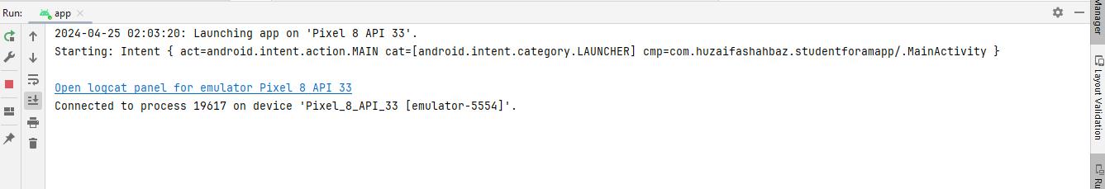
Output:
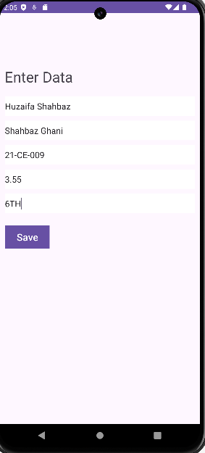
Home Task: Design a simple login app to check entered username and password, if user entered wrong user name or password then show Toast message “You have entered wrong user name or password”, on successful entering the user name and password, bring to home page.
JAVA CODE OF LOGIN ACTIVITY (STUDENT FORM):
package com.huzaifashahbaz.studentforamapp;
android.content.Intent; import android.os.Bundle; import android.view.View; import android.widget.EditText; import android.widget.Toast; import androidx.activity.EdgeToEdge; import androidx.appcompat.app.AppCompatActivity;
import androidx.core.graphics.Insets; import androidx.core.view.ViewCompat; import androidx.core.view.WindowInsetsCompat; public class MainActivity_studentform extends AppCompatActivity { private static final String
CORRECT_USERNAME="huzaifashahbaz786";
private static final String CORRECT_PASSWORD="21CE009";
@Override
protected void onCreate(Bundle savedInstanceState) { super.onCreate(savedInstanceState); setContentView( R.layout.activity_main_studentform );
}
public void login(View view){ EditText
usernameEditText=findViewById(R.id.usernameEditText);
EditText
passwordEditText=findViewById(R.id.passwordEditText);
String enteredUsername=usernameEditText.getText().toString();
String enteredPassword=passwordEditText.getText().toString();

if(enteredUsername.equals(CORRECT_USERNAME)&&enteredPasswo
rd.equals(CORRECT_PASSWORD)){
Intent intent=new Intent(this,MainActivity.class); startActivity(intent);
finish();
}else{
Toast.makeText( this, "You have entered wrong username or password", Toast.LENGTH_SHORT ).show();
}
}
}
XML CODE OF LOGIN ACTIVITY (STUDENT FORM):
<LinearLayout xmlns:android="http://schemas.android.com/apk/res/android" xmlns:app="http://schemas.android.com/apk/res-auto" xmlns:tools="http://schemas.android.com/tools" android:layout_width="match_parent" android:layout_height="match_parent" android:orientation="vertical" android:padding="16dp" tools:context=".MainActivity">
<EditText android:id="@+id/usernameEditText" android:layout_width="match_parent" android:layout_height="wrap_content" android:hint="Username" android:minHeight="48dp" />
<EditText android:id="@+id/passwordEditText" android:layout_width="match_parent" android:layout_height="wrap_content" android:hint="Password" android:inputType="textPassword" android:minHeight="48dp" />
<Button android:layout_width="wrap_content" android:layout_height="wrap_content"
android:text="Login"
android:onClick="login"
/>
</LinearLayout>
Result:
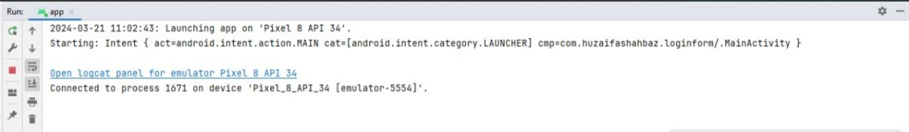

OUTPUT:
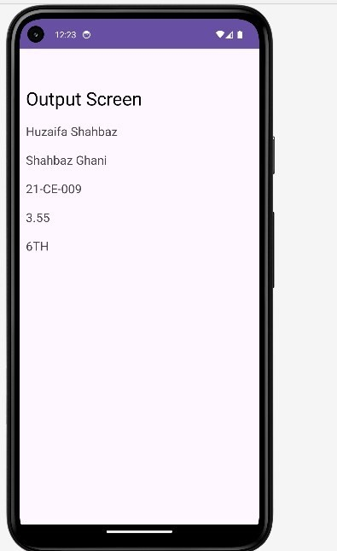
CONCLUSION:
In conclusion, we had done the intent app by making student’s registeration form and login id.By the help of java and xml.

LAB REPORT#5
List View and Array Adapter
Introduction: Android List View is a view which groups several items and display them in vertical scrollable list. The list items are automatically inserted to the list using an Adapter that pulls content from a source such as an array or database. Android provides several subclasses of Adapter that are useful for retrieving different kinds of data and building views for an Adapter-View ( i.e. List-View or Grid-View) The common adapters are • Array-Adapter • Base-Adapter You can use this adapter when your data source is an array. By default, ArrayAdapter creates a view for each array item by calling toString() on each item and placing the contents in a TextView. Consider you have an array of strings you want to display in a ListView, initialize a new ArrayAdapter using a constructor to specify the layout for each string and the string array. ArrayAdapter adapter = new ArrayAdapter(this, R.layout.history_item_layout,countryArray); Objectives of the experiment: •To get basic understanding List View and Adapter • To be able to use List View and Adapter in android applications. • To get to know about the benefits related to List View.
Tools: Android Studio Iguana
Class Task Country List XML CODE OF MAIN ACTIVITY: <?xml version="1.0" encoding="utf-8"?>
<LinearLayout xmlns:android="http://schemas.android.com/apk/res/android"
xmlns:tools="http://schemas.android.com/tools"
xmlns:app="http://schemas.android.com/apk/res-auto"
android:orientation="vertical"
android:layout_width="match_parent"
android:layout_height="match_parent">
<TextView
android:layout_width="match_parent"
android:layout_height="wrap_content"
android:id="@+id/list_tv"
android:text="Country List"
android:textSize="32sp"
android:layout_marginTop="@dimen/font_size"/>
<ListView
android:layout_width="match_parent"
android:layout_height="match_parent"
android:id="@+id/country_list"/>
</LinearLayout>

JAVA CODE OF MAIN ACTIVITY: package CountryList;
import android.os.Bundle;
import android.widget.ArrayAdapter;
import android.widget.ListView;
import androidx.appcompat.app.AppCompatActivity;
import com.huzaifashahbaz.nameapp.R;
import java.util.ArrayList;
public class MainActivity extends AppCompatActivity {
protected void onCreate(Bundle savedInstanceState)
{
super.onCreate(savedInstanceState);
setContentView(R.layout.activity_country);
ListView countryList=findViewById(R.id.country_list);
ArrayList<String>countryArray=new ArrayList<String>();
countryArray.add("Pakistan");
countryArray.add("Saudi Arabia");
countryArray.add("China");
ArrayAdapter adapter=new ArrayAdapter(this,
R.layout.activity_country,countryArray);
countryList.setAdapter(adapter);
}
}

Result:
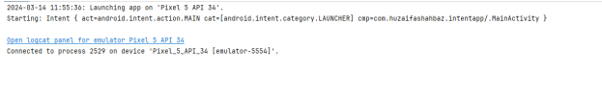
OUTPUT:
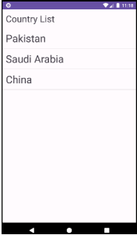
Home Task:
Consider your assignment # 1 and implement the same task using list view on history activity and use array list to add count in main activity and pass this array list to history activity.
Hint: ArrayList historyAL = getIntent().getStringArrayListExtra(TasbeeActivity.MAIN_TO_HISTORY_STRING_KEY)

XML CODE OF MAIN ACTIVITY:
<?xml version="1.0" encoding="utf-8"?>
<LinearLayout xmlns:android="http://schemas.android.com/apk/res/android"
xmlns:app="http://schemas.android.com/apk/res-auto"
xmlns:tools="http://schemas.android.com/tools"
android:layout_width="match_parent"
android:layout_height_="match_parent"
android:gravity="center"
android:orientation="vertical"
tools:context=".MainActivity">
<TextView
android:id="@+id/textView"
android:layout_width="131dp"
</ android:layout_height="wrap_content"
android:text="TextView"
android:textColorLink="#805F5F"
tools:layout_editor_absoluteX="267dp"
tools:layout_editor_absoluteY="142dp" />
<LinearLayout
android:layout_width="match_parent"
android:layout_height="wrap_content"
android:orientation="horizontal">
<Button
android:id="@+id/btn_count_1"
android:layout_width="245dp"
android:layout_height="wrap_content"
android:onClick="onPressCountBtn"
android:text="Count"
tools:layout_editor_absoluteX="198dp"
tools:layout_editor_absoluteY="156dp" />
<Button
android:id="@+id/btn_Rest_1"
android:layout_width="142dp"
android:layout_height="wrap_content"
android:onClick="onPressResetBtn"
android:text="Reset"
tools:layout_editor_absoluteX="247dp"
tools:layout_editor_absoluteY="224dp" />
</LinearLayout>
<Button
android:id="@+id/btnViewhistory"
android:layout_width="match_parent"
android:layout_height="wrap_content"
android:onClick="onPressHistorybtn"
android:text="View history"
tools:layout_editor_absoluteX="296dp"
tools:layout_editor_absoluteY="153dp" />
</LinearLayout>
JAVA CODE OF MAIN ACTIVITY:
package com.huzaifashahbaz.mytasbeehapp1;
import android.os.Bundle;
import android.os.PersistableBundle;
import android.widget.Button;
import android.widget.TextView;
import android.widget.Toast;
import androidx.activity.EdgeToEdge;
import androidx.annotation.Nullable;
import androidx.appcompat.app.AppCompatActivity;
import androidx.core.graphics.Insets;
import androidx.core.view.ViewCompat;
import androidx.core.view.WindowInsetsCompat;
public class MainActivity extends AppCompatActivity {
TextView tvCount;
Button btnCount,btnReset,btnViewHistory;
int count=0;
@Override
protected void onCreate(Bundle savedInstanceState) {
super.onCreate( savedInstanceState );
setContentView( R.layout.activity_main );
tvCount=findViewById(R.id.textView);
}
public void onPressResetBtn(View View){
count=0;
tvCount.setText("Count:"+count);
}
public void onPressHistorybtn(View view){
Toast.makeText( this, "JAZAKALLAJKHAIR", Toast.LENGTH_SHORT ).show();
}
public void onPressCountBtn(View View){
count++;
tvCount.setText("Count:"+count);
}
}

Results:


OUTPUT:
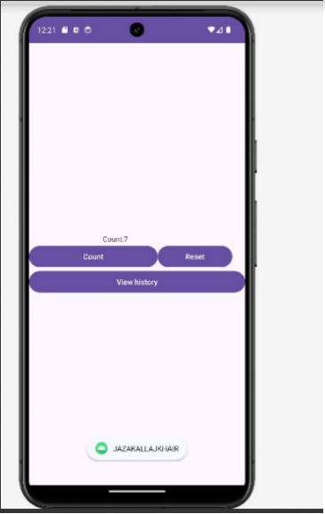

XML CODE OF HISTORY ACTIVITY:
<?xml version="1.0" encoding="utf-8"?>
<LinearLayout xmlns:android="http://schemas.android.com/apk/res/android"
xmlns:app="http://schemas.android.com/apk/res-auto"
xmlns:tools="http://schemas.android.com/tools"
android:layout_width="match_parent"
android:layout_height="match_parent"
android:gravity="center"
android:orientation="vertical"
tools:context=".MainActivity">
<TextView
android:id="@+id/textView"
android:layout_width="131dp"
android:layout_height="wrap_content"
android:text="TextView"
android:textColorLink="#805F5F"
tools:layout_editor_absoluteX="267dp"
tools:layout_editor_absoluteY="142dp" />
<LinearLayout
android:layout_width="match_parent"
android:layout_height="wrap_content"
android:orientation="horizontal">
<Button
android:id="@+id/btnViewhistory"
android:layout_width="match_parent"
android:layout_height="wrap_content"
android:onClick="onPressHistorybtn"
android:text="View history"
tools:layout_editor_absoluteX="296dp"
tools:layout_editor_absoluteY="153dp" />
</LinearLayout>
<Button
android:id="@+id/btnIncrement"
android:layout_width="match_parent"
android:layout_height="wrap_content"
android:onClick="onPressIncrementbtn"
android:text="Increment"
tools:layout_editor_absoluteX="296dp"
tools:layout_editor_absoluteY="153dp" />
</LinearLayout>
JAVA CODE OF ACTIVITY HISTORY:
package com.huzaifashahbaz.assginmentoftabseehcounter;
import android.os.Bundle;
import android.view.View;
import android.widget.Button;
import android.widget.TextView;
import androidx.activity.EdgeToEdge;
import androidx.appcompat.app.AppCompatActivity;
import androidx.core.graphics.Insets;
import androidx.core.view.ViewCompat;
import androidx.core.view.WindowInsetsCompat;
public class historyActivity extends AppCompatActivity {
TextView tvCount;
Button btnIncrement,btnViewHistory;
int count=0;
@Override
protected void onCreate(Bundle savedInstanceState) {
super.onCreate( savedInstanceState );
EdgeToEdge.enable( this );
setContentView( R.layout.activity_history );
tvCount=findViewById( R.id.textView );
}
void onPressHistorybtn(View view){
count=0;
tvCount.setText( "Count:"+count );
}
void onPressIncrementbtn(View view){
count++;
tvCount.setText("Count:"+count);
}
}
RESULTS: 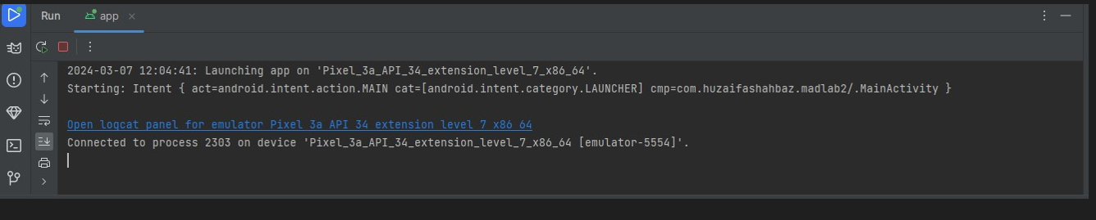
OUTPUT: 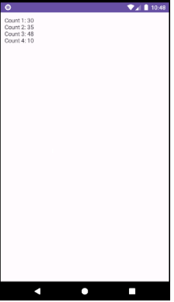

XML CODE OF TASBEEHARRAY ACTIVITY:

<?xml version="1.0" encoding="utf-8"?>
<LinearLayout xmlns:android="http://schemas.android.com/apk/res/android"
xmlns:app="http://schemas.android.com/apk/res-auto"
xmlns:tools="http://schemas.android.com/tools"
android:layout_width="match_parent"
android:layout_height="match_parent"
android:gravity="center"
android:orientation="vertical"
tools:context=". TASBEEHARRAY Activity">
<TextView
android:id="@+id/historytext"
android:layout_width="match_parent"
android:layout_height="match_parent"
android:text=""
android:textSize="20sp"
android:textStyle="bold"
android:fontFamily="causal"/>
<LinearLayout
android:layout_width="match_parent"
android:layout_height="wrap_content"
android:orientation="horizontal">
</LinearLayout>
JAVA CODE OF TASBEEHARRAY ACTIVITY:
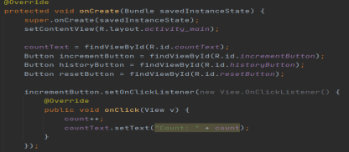

package com.huzaifashahbaz.assginmentoftabseehcounter;
import android.os.Bundle;
import android.view.View;
import android.widget.Button;
import android.widget.TextView;
import androidx.activity.EdgeToEdge;
import androidx.appcompat.app.AppCompatActivity;
import androidx.core.graphics.Insets;
import androidx.core.view.ViewCompat;
import androidx.core.view.WindowInsetsCompat;
public class TASBEEHARRAYActivity extends AppCompatActivity {
TextView tvCount;
Button btnIncrement,btnViewHistory;
int count=0;
@Override
protected void onCreate(Bundle savedInstanceState) {
super.onCreate( savedInstanceState );
setContentView( R.layout.activity_tasbeeharray );
countText=findbyViewById(R.id.countText);
Button incrementButton=findbyViewById(R.id. incrementButton);
Button historyButton=findbyViewById(R.id. historyButton);
Button resetButton=findbyViewById(R.id. resetButton);
incrementButton.setOnClickListener(new View.OneClickListener())
{
@Override
public void onClick(View v)
{
count++;
CountText.setText("Count:"+count);
}
});
historyButton.setOnClickListener(new View.OneClickListener())
{
@Override
public void onClick(View v)
{
Intent intent=newIntent(tasbeeharrayactivity,this,historyactivity.class);
Intent.putIntegerArrayListExtra("Counthistory", historyactivity);
StartActivity(intent);
}
});
resetButton.setOnClickListener(new View.OneClickListener())
{
@Override
public void onClick(View v)
{
CountHistory.add(count);
Count=0;
countText.setText("Count:0");
}
});

}
void onPressHistorybtn(View view){
count=0;
tvCount.setText( "Count:"+count );
}
void onPressIncrementbtn(View view){
count++;
tvCount.setText("Count:"+count);
}
}
RESULTS:

OUTPUT:
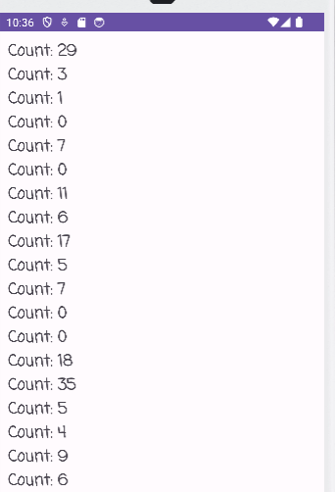

Conclusion:
In conclusion ,we had know about the functions and working of List View and Array Adapter.We also make the tasbeeh counter app by using list view and array adapter in mobile application development by using java code and xml linear layout code.

LAB REPORT#6
List View and BaseAdapter
Introduction: Android ListView is a view which groups several items and display them in vertical scrollable list.The list items are automatically inserted to the list using an Adapter that pulls content from a source such as an array or database. Android provides several subclasses of Adapter that are useful for retrieving different kinds of data and building views for an AdapterView ( i.e. ListView or GridView) The common adapters are • ArrayAdapter • BaseAdapter BaseAdapter is a common base class of a general implementation of an Adapter that can be used in ListView, GridView, Spinner etc. Whenever you need a customized list in a ListView or customized grids in a GridView you create your own adapter and extend base adapter in that.Base Adapter can be extended to create a custom Adapter for displaying a custom list item. Objectives of the experiment: • To get basic understanding List View and Base Adapter • To be able to use List View and Base Adapter in android applications. • To get to know about the benefits related to List View.
Tools: Android Studio Iguana
Class Task Operating System XML CODE OF MAIN ACTIVITY:
<?xml version="1.0" encoding="utf-8"?>
<LinearLayout xmlns:android="http://schemas.android.com/apk/res/android"
xmlns:app="http://schemas.android.com/apk/res-auto"
xmlns:tools="http://schemas.android.com/tools"
android:layout_width="match_parent"
android:layout_height="match_parent"
android:fitsSystemWindows="true"
android:orientation="vertical"
tools:context="OperatingSystemCustomAdapter.OperatingSystemActivity">
<TextView
android:layout_width="match_parent"
android:layout_height="wrap_content"
android:textSize="32sp"
android:text="Operation Systems">
</TextView>
<ListView
android:id="@+id/os_list_view"
android:layout_width="match_parent"
android:layout_height="match_parent"/>
</LinearLayout>
XML CODE OF ACTIVITY OF OPERATING SYSTEM:
<?xml version="1.0" encoding="utf-8"?>
<LinearLayout xmlns:android="http://schemas.android.com/apk/res/android"
xmlns:app="http://schemas.android.com/apk/res-auto"
xmlns:tools="http://schemas.android.com/tools"
android:layout_width="match_parent"
android:layout_height="wrap_content"
android:orientation="horizontal">
<ImageView
android:id="@+id/os_image_view"
android:layout_width="wrap_content"
android:layout_height="wrap_content"
<TextView
android:id="@+id/os_name_text_view"
android:layout_gravity="center"
android:layout_width="wrap_content"
android:layout_height="wrap_content"
android:text="TextView">
</TextView>
</LinearLayout>

JAVA CODE OF MAIN ACTIVITY:
package com.huzaifashahbaz.madlab6;
import android.os.Bundle;
import android.widget.ListView;
import androidx.appcompat.app.AppCompatActivity;
import java.util.ArrayList;
public class MainActivity2 extends AppCompatActivity {
@Override
protected void onCreate(Bundle savedInstanceState) {
super.onCreate(savedInstanceState);
setContentView(R.layout.activity_main2);
ArrayList<String> osAL = new ArrayList<String>();
osAL.add("Android");
osAL.add("iOS");
osAL.add("Windows");
ArrayList<Integer> osIconAL = new ArrayList<Integer>();
osIconAL.add(R.mipmap.os_w);
osIconAL.add(R.mipmap.os_ios);
osIconAL.add(R.mipmap.os_windows);
OperatingSystemCustomAdapter adapter = new OperatingSystemCustomAdapter(this, osAL, osIconAL);
ListView listView = findViewById(R.id.os_list_view);
listView.setAdapter(adapter);
}
}
JAVA CODE OF BASE ADAPTER:
package com.huzaifashahbaz.madlab6;
import android.content.Context;
import android.view.LayoutInflater;
import android.view.View;
import android.view.ViewGroup;
import android.widget.BaseAdapter;
import android.widget.ImageView;
import android.widget.TextView;
import java.util.ArrayList;
public class OperatingSystemCustomAdapter extends BaseAdapter {
private Context context;
private ArrayList<OperatingSystem> operatingSystems;
public OperatingSystemCustomAdapter(Context context, ArrayList<OperatingSystem> operatingSystems) {
this.context = context;
this.operatingSystems = operatingSystems;
}
@Override
public int getCount() {
return operatingSystems.size();
}
@Override
public Object getItem(int position) {
return operatingSystems.get(position);
}
@Override
public long getItemId(int position) {
return position;
}
@Override
public View getView(int position, View convertView, ViewGroup parent) {
if (convertView == null) {
convertView = LayoutInflater.from(context).inflate(R.layout.list_item_operating_system, parent, false);
}
OperatingSystem os = (OperatingSystem) getItem(position);
TextView nameTextView = convertView.findViewById(R.id.os_name_text_view);
ImageView iconImageView = convertView.findViewById(R.id.os_icon_image_view);
nameTextView.setText(os.getName());
iconImageView.setImageResource(os.getIconResourceId());
return convertView;
}
}
Result:

OUTPUT:
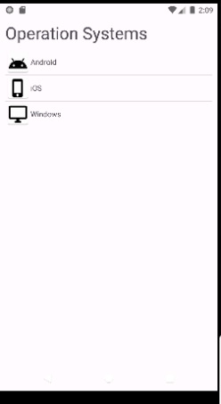
HOME TASK:
Design a list view to show country flag, name, and their capital city as shown in the figure below. Add at least three countries into the list.
XML CODE OF MAIN ACTIVITY:
<?xml version="1.0" encoding="utf-8"?>
<LinearLayout xmlns:android="http://schemas.android.com/apk/res/android"
xmlns:app="http://schemas.android.com/apk/res-auto"
xmlns:tools="http://schemas.android.com/tools"
android:layout_width="match_parent"
android:layout_height="match_parent"
android:fitsSystemWindows="true"
android:orientation="vertical"
android:padding="1mm"
tools:context=".MainActivity">
<TextView
android:layout_width="match_parent"
android:layout_height="wrap_content"
android:textSize="32sp"
android:layout_marginBottom="1mm"
android:text="Countries List">
</TextView>
<ListView
android:id="@+id/os_list_view"
android:Layout_width="match_parent"
android:layout_height="match_parent">
</ListView>
</LinearLayout>
XML CODE OF COUNTRY_ITEM ACTIVITY:
<?xml version="1.0" encoding="utf-8"?>
<LinearLayout xmlns:android="http://schemas.android.com/apk/res/android"
xmlns:app="http://schemas.android.com/apk/res-auto"
xmlns:tools="http://schemas.android.com/tools">
<Linearlayout>
<TextView
android:id="@+id/os_name_text_view"
android:layout_width="wrap_content"
android:layout_height="wrap_content"
android:text="TextView"
android:textSize="25sp" />
<TextView android:id="@+id/subtext">
</TextView>
</Linearlayout>
<EditText
android:id="@+id/editTextText"
android:layout_width="wrap_content"
android:layout_height="wrap_content"
android:layout_weight="1"
android:ems="10"
android:inputType="text"
android:text="Name" />
</LinearLayout>

JAVA CODE OF MAIN ACTIVITY:
package com.huzaifashahbaz.madlab6;
import android.os.Bundle;
import android.widget.ListView;
import androidx.appcompat.app.AppCompatActivity;
import java.util.ArrayList;
public class MainActivity2 extends AppCompatActivity {
@Override
protected void onCreate(Bundle savedInstanceState) {
super.onCreate( savedInstanceState );
setContentView( R.layout.activity_main2 );
ArrayList<String> osAL = new ArrayList<>();
osAL.add( "Pakistan" );
osAL.add( "China" );
osAL.add( "England" );
ArrayList<String> subtext = new ArrayList<>();
subtext.add( "Islamabad" );
subtext.add( "Beijing" );
subtext.add( "London" );
ArrayList<Integer> osIconAL = new ArrayList<>();
osIconAL.add( R.mipmap.Pakistan );
osIconAL.add( R.mipmap.China );
osIconAL.add( R.mipmap.England );
OSAdapter adapter = new OSAdapter( this, osAL, subtext, osIconAL );
listView listView = findViewById( R.id.os_list_view );
listView.setAdapter( adapter );
}
}

JAVA CODE OF CUSTOM ADAPTER:
package com.huzaifashahbaz.madlab6;
import android.os.Bundle;
import android.widget.ListView;
import androidx.appcompat.app.AppCompatActivity;
import java.util.ArrayList;
public class OperatingSystemCustomAdapter extends BaseAdapter {
ArrayList<String> osAL;
ArrayList<Integer> osIocnAL;
LayoutInflater inflater;
public OperatingSystemCustomAdapter(Context context, ArrayList<String> osAL, ArrayList<Integer> osIocnAL) {
this.osAL = osAL;
this.osIocnAL = osIocnAL;
inflater = LayoutInflater.from(context);
}
@Override
public int getCount() {
return osAL.size();
}
@Override
public Object getItem(int position) {
return null;
}
@Override
public long getItemId(int position) {
return 0;
}
@Override
public View getView(int position, View convertView, ViewGroup parent) {
convertView = inflater.inflate(R.layout.os_item_layout, null);
ImageView countryFlagImageView =
convertView.findViewById(R.id.os_image_view);
TextView countryTV = convertView.findViewById(R.id.os_name_text_view);
countryFlagImageView.setImageResource(osIocnAL.get(position));
countryTV.setText(osAL.get(position));
return convertView;
}
}

Result:
OUTPUT:
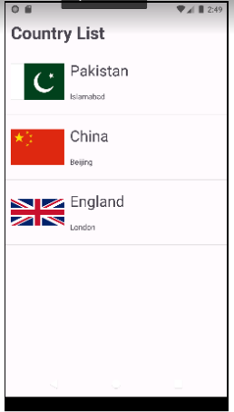
Conclusion:
In conclusion, we had known the techniques of List View and base Adapter in Android Studio. We also me the two apps country list and operating system by using List View and base Adapter also we see their function and working in android studio.

LAB REPORT#7
Shared Preferences
Introduction: Android provides many ways of storing data of an application. One of this way is called Shared Preferences. Shared Preferences allow you to save and retrieve data in the form of key, value pair.The first parameter is the key and the second parameter is the MODE.You can save something in the sharedpreferences by using SharedPreferences. Editor class. You will call the edit method of SharedPreference instance and will receive it in an editor object. Its syntax isEditor editor = sharedpreferences.edit(); editor.putString("key", "value"); editor.commit(); Objectives of the experiment: •To get basic understanding regarding Shared Preferences •To get basic understanding regarding how data is saved and retrieved • To get to know about the benefits related to Shared Preferences
Tools: Android Studio Iguana
Class Task:
Shared Preferences:
XML CODE OF MAIN ACTIVITY:
<?xml version="1.0" encoding="utf-8"?>
<LinearLayout xmlns:android="http://schemas.android.com/apk/res/android"
xmlns:app="http://schemas.android.com/apk/res-auto"
xmlns:tools="http://schemas.android.com/tools"
android:layout_width="match_parent"
android:layout_height="match_parent"
android:orientation="vertical"
android:padding="20dp"
tools:context=".MainActivity">
<EditText
android:id="@+id/user_name"
android:layout_width="match_parent"
android:layout_height="wrap_content"
android:ems="10"
android:inputType="textPersonName"
android:text="User Name" />
<EditText
android:id="@+id/pass_word"
android:layout_width="match_parent"
android:layout_height="wrap_content"
android:ems="10"
android:inputType="textPersonName"
android:text="PassWord" />
<Button
android:id="@+id/save_btn"
android:layout_width="match_parent"
android:layout_height="wrap_content"
android:onClick="saveButton"
android:text="Save" />
<Button
android:id="@+id/restore_btn"
android:layout_width="match_parent"
android:layout_height="wrap_content"
android:onClick="restoreButton"
android:text="Get" />
<Button
android:id="@+id/delete_btn"
android:layout_width="match_parent"
android:layout_height="wrap_content"
android:onClick="deleteButton"
android:text="Delete" />
</LinearLayout>

JAVA CODE OF MAIN ACTIVITY:
package com.huzaifashahbaz.SharedPreferences;
import android.os.Bundle;
import android.view.View;
import android.widget.Button;
import android.widget.EditText;
import android.widget.Toast;
import androidx.appcompat.app.AppCompatActivity;
class PrefActivity extends AppCompatActivity {
EditText userName, password;
Button save, restore, delete;
@Override
protected void onCreate(Bundle savedInstanceState) {
super.onCreate(savedInstanceState);
setContentView(R.layout.activity_main);
userName = findViewById(R.id.user_name);
password = findViewById(R.id.pass_word);
save = findViewById(R.id.save_btn);
restore = findViewById(R.id.save_btn);
delete = findViewById(R.id.delete_btn);
}
public void saveButton(View view){
String userNameStr = userName.getText().toString();
String passWordStr = password.getText().toString();
if(!userNameStr.isEmpty() &&
!passWordStr.isEmpty()){
if(MySharedPrefs.setUserNamePW(this, userNameStr, passWordStr)){
Toast.makeText(this, "Successfully Saved",
Toast.LENGTH_SHORT).show();
} else {
Toast.makeText(this, "Not Successfully Saved",
Toast.LENGTH_SHORT).show();
}
}
}
public void restoreButton(View view){
String[] userNamePW = MySharedPrefs.getUserNamePW(this);
if(!userNamePW[0].isEmpty() && !userNamePW[1].isEmpty()){
userName.setText(userNamePW[0]);
password.setText(userNamePW[1]);
}
}
public void deleteButton(View view){
if(MySharedPrefs.removeUserNamePW(this)){
userName.setText("");
password.setText("");
Toast.makeText(this, "Successfully Deleted",
Toast.LENGTH_SHORT).show();
} else {
Toast.makeText(this, "Not Successfully Deleted",
Toast.LENGTH_SHORT).show();
}
}
}

JAVA CODE OF MY Shared Preferences CLASS:
package com.huzaifashahbaz.SharedPreferences;
import android.content.Context;
import android.content.SharedPreferences;
public class MySharedPrefs {
public static final String USER_NAME = "userName";
public static final String PASS_WORD = "passWord";
public static boolean setUserNamePW(Context context, String userName, String
passWord){
SharedPreferences prefs = context.getSharedPreferences("MyPrefs",
context.MODE_PRIVATE);
SharedPreferences.Editor editor = prefs.edit();
editor.putString(USER_NAME, userName);
editor.putString(PASS_WORD, passWord);
return editor.commit();
}
public static String[] getUserNamePW(Context context){
SharedPreferences prefs = context.getSharedPreferences("MyPrefs",
context.MODE_PRIVATE);
String[] userNamePW = new String[2];
userNamePW[0] = prefs.getString(USER_NAME, "");
userNamePW[1] = prefs.getString(PASS_WORD, "");
return userNamePW;
}
public static boolean removeUserNamePW(Context context){
SharedPreferences prefs = context.getSharedPreferences("MyPrefs",
context.MODE_PRIVATE);
SharedPreferences.Editor editor = prefs.edit();
editor.remove(USER_NAME);
editor.remove(PASS_WORD);
return editor.commit();
}
}

Results:
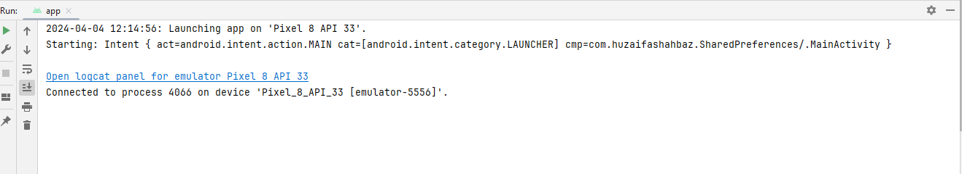
OUTPUT:
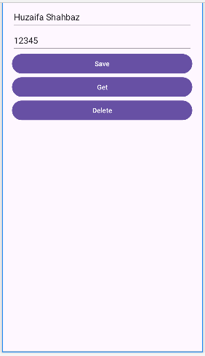
Home Task: Use Tasbeeh app and use shared preference to store history. Note: Shared Preference can only store strings.
JAVA CODE OF MAIN ACTIVITY:
package com.huzaifashahbaz.tasbeehappsharedpreferences;
import android.content.Intent;
import android.os.Bundle;
import android.view.View;
import android.widget.Button;
import android.widget.TextView;
import androidx.activity.EdgeToEdge;
import androidx.appcompat.app.AppCompatActivity;
import androidx.core.graphics.ColorUtils;
import androidx.core.graphics.Insets;
import androidx.core.view.ViewCompat;
import androidx.core.view.WindowInsetsCompat;
import java.util.ArrayList;
public class MainActivity extends AppCompatActivity {
private TextView countView;//initailize the textview
private Button countButton;//initialize the countbutton
private Button resetButton;//initialize the resetbutton
private Button viewHistoryButton;//initialize the viewhistoryButton
private int count=0;//initialize count
private ArrayList<CountEntry>countHistory;//initialize arraylist of counthistory
@Override
protected void onCreate(Bundle savedInstanceState) {
super.onCreate(savedInstanceState);
setContentView(R.layout.activity_main);//main activity java file
countHistory=CountSharedPreferences.getCountHistory(this);
//DEFINE UI COMPONENTS
countView=findViewById(R.id.count);//countview java file
countButton=findViewById(R.id.count_btn);//count_btn java file
resetButton=findViewById(R.id.reset_btn);//reset_btn java file
viewHistoryButton=findViewById(R.id.history_btn);//history_btn java file
//SET UP INITIAL COUNT
updateCountView();
//BUTTON LISTENERS
//COUNTBUTTON CLICKLISTENER FUNCTION
countButton.setOnClickListener(new View.OnClickListener() {
@Override
public void onClick(View view) {
count++;
updateCountView();
}
});
//RESETBUTTON CLICKLISTENER FUNCTION
resetButton.setOnClickListener(new View.OnClickListener() {
@Override
public void onClick(View view) {
countHistory.add(new CountEntry(count,System.currentTimeMillis()));
CountSharedPreferences.saveCountHistory(MainActivity.this,countHistory);
count=0;
updateCountView();
}
});
//HISTORYBUTTON ONCLICKLISTENERFUNCTION
viewHistoryButton.setOnClickListener(new View.OnClickListener() {
@Override
public void onClick(View view) {
Intent countIntent=new Intent(MainActivity.this,HistoryActivity.class);
startActivity(countIntent);
}
});
}
private void updateCountView()
{
countView.setText("Count:"+count);
}
}
JAVA CODE OF HISTORY ACTIVITY:
package com.huzaifashahbaz.tasbeehappsharedpreferences;
import android.content.DialogInterface;
import android.os.Bundle;
import android.view.View;
import android.widget.AdapterView;
import android.widget.ListView;
import androidx.activity.EdgeToEdge;
import androidx.appcompat.app.AlertDialog;
import androidx.appcompat.app.AppCompatActivity;
import androidx.core.graphics.Insets;
import androidx.core.view.ViewCompat;
import androidx.core.view.WindowInsetsCompat;
import java.text.SimpleDateFormat;
import java.util.ArrayList;
import java.util.Date;
import java.util.Locale;
public class HistoryActivity extends AppCompatActivity {
@Override
protected void onCreate(Bundle savedInstanceState) {
super.onCreate(savedInstanceState);
setContentView(R.layout.activity_history);//historyactivity javafile create
ListView historylist=findViewById(R.id.count_list);//count_list java file create
ArrayList <CountEntry> countHistory= CountSharedPreferences.getCountHistory(this);//arraylist
if (CountHistory !=null)
{
CountHistoryAdapter historyAdapter = new CountHistoryAdapter(this,R.layout.count_list_item,countHistory);//counthistoryadapter
historylist.setAdapter(historyAdapter);
historylist.setOnItemClickListener(new AdapterView.OnItemClickListener() {
@Override
public void onItemClick(AdapterView<?> adapterView, View view, int i, long l) {
showDateTimeDialog(countHistory.get(position));//datetimedialog
}
});
}
}
private void showDateTimeDialog(countEntry entry)
{
String formattedDate=formatDate(entry.getTimestamp());//string of formatted date
String dialogMessage="Count saved at:" + formattedDate;//string of dialogMessage
//build and show alertdialog
AlertDialog.Builder builder=new AlertDialog.Builder(this);
builder.setMessage(dialogMessage);
builder.setMessage(dialogMessage)
.setTitle("Count Information")//title of builder
.setPositiveButton("OK", new DialogInterface.OnClickListener() {//positive button of dialog interface
public void onClick(DialogInterface dialogInterface, int i) {
//user clicked on button
dialog.dismiss();
}
});
AlertDialog dialog= builder.create();//buildercreate of dialog
dialog.show();
}
private String formatDate(long timestamp)
{
SimpleDateFormat sdf=new SimpleDateFormat("yyyy-MM-dd HH:mm:ss", Locale.getDefault());
return sdf.format(new Date(timestamp));
}
}
CountsharedPreferneces:
package com.huzaifashahbaz.tasbeehappsharedpreferences;
import android.content.Context;
import android.content.SharedPreferences;
import java.util.ArrayList;
import java.util.HashSet;
import java.util.Set;
public class CountSharedPreferences {
private static final String PREF_NAME="CountPreferences";//string prefname
private static final String COUNT_HISTORY_KEY="countHistory";//string counthistory
public static void saveCountHistory(Context context, ArrayList<CountEntry> countHistory)
{
SharedPreferences.Editor editor=context.getSharedPreferences(PREF_NAME,context.MODE_PRIVATE).edit();//shared[reference editior
Set<String> countHistorySet=new HashSet<>();//counthistoryset
for (CountEntry entry:CountHistory)//for loop
{
countHistorySet.add(serializeCountEntry(entry));
}
editor.putString(COUNT_HISTORY_KEY,countHistorySet);
editor.apply();
}
public static ArrayList<CountEntry>getCountHistory(Context context)
{
SharedPreferences prefs= context.getSharedPreferences(PREF_NAME,Context.MODE_PRIVATE);
Set<String> countHistorySet=prefs.getStringSet(COUNT_HISTORY_KEY,null);
if (countHistorySet !=null)
{
ArrayList<CountEntry> countHistory=new ArrayList<>();
for (String serializiedEntry:countHistory)
{
countHistory.add(deserializedCountEntry(serializiedEntry));
}
return countHistory;
}
return new ArrayList<>();
}
private static String serializeCountEntry(CountEntry entry)
{
return entry.getCount()+ ","+entry.getTimestamp();
}
private static CountEntry deserializedCountEntry(String serializedEntry)
{
String[] parts =serializedEntry.split(",");
int count=Integer.parseInt(parts[0]);
long timestamp =Long.parseLong(parts[1]);
return new CountEntry(count,timestamp);
}
}
XML CODE OF MAIN ACTIVITY:
<?xml version="1.0" encoding="utf-8"?>
<LinearLayout xmlns:android="http://schemas.android.com/apk/res/android"
xmlns:app="http://schemas.android.com/apk/res-auto"
xmlns:tools="http://schemas.android.com/tools"
android:layout_width="match_parent"
android:layout_height="match_parent"
android:orientation="vertical"
android:padding="2mm"
tools:context=".MainActivity">
<LinearLayout
android:layout_width="wrap_content"
android:layout_height="wrap_content"
android:layout_marginHorizontal="14mm"
android:layout_marginTop="14mm"
android:orientation="vertical"
android:layout_gravity="center">
<TextView
android:id="@+id/app_title"
android:layout_width="match_parent"
android:layout_height="wrap_content"
android:gravity="center"
android:textSize="35sp"
android:textStyle="bold"
android:fontfamily="causal"
android:text="Tasbeeh App"/>
<TextView
android:id="@+id/count"
android:layout_width="match_parent"
android:layout_height="wrap_content"
android:layout_marginTop="15mm"
android:gravity="center"
android:textSize="25sp"
android:textStyle="bold"
android:fontFamily="monospace"
android:text="Count:0"/>
<LinearLayout
android:layout_width="wrap_content"
android:layout_height="wrap_content"
android:orientation="horizontal"
android:layout_gravity="center"
android:layout_marginTop="14mm">
<Button
android:id="@+id/count_btn"
android:layout_width="wrap_content"
android:layout_height="match_parent"
android:layout_marginHorizontal="1mm"
android:text="Alhamdulillah"
android:textSize="18sp"
android:fontFamily="casual"
android:textStyle="bold"/>
<Button
android:id="@+id/reset_btn"
android:layout_width="wrap_content"
android:layout_height="wrap_content"
android:layout_marginHorizontal="1mm"
android:text="Reset"
android:textSize="18sp"
android:fontFamily="casual"
android:textStyle="bold"/>
</LinearLayout>
<LinearLayout
android:layout_width="wrap_content"
android:layout_height="wrap_content"
android:orientation="horizontal"
android:layout_gravity="center"
android:layout_marginTop="14mm">
<Button
android:id="@+id/history_btn"
android:layout_width="wrap_content"
android:layout_height="wrap_content"
android:layout_marginHorizontal="18sp"
android:fontFamily="casual"
android:textStyle="bold"/>
</LinearLayout>
</LinearLayout>
</LinearLayout>

Results:

OUTPUT:
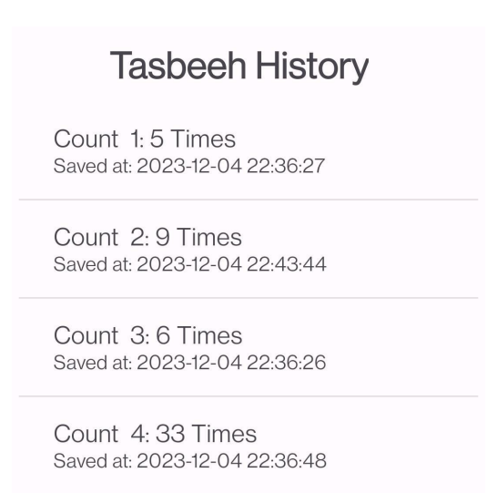
Conclusion: In conclusion, we had learned the shared preferences in mobile app.Also we know the working and function of tasbeehcounter and student form by using Java Code and XML linear layout.

